DONATION INFORMATION FORM
After sending an e transfer, please email this completed form to treasurer@detweilermeetinghouse.ca

Amount: $ _____________ Donations $20 and more will receive a tax receipt

Your name, printed: __________________________________________

Email: ___________________________________________

Address: ___________________________________________________________

Postal Code: _________________ Phone/Cell: _________________________

Thank you for your support!
At our summer music programs, donations of $20 and more by cheque or identified cash, are eligible for a tax receipt.

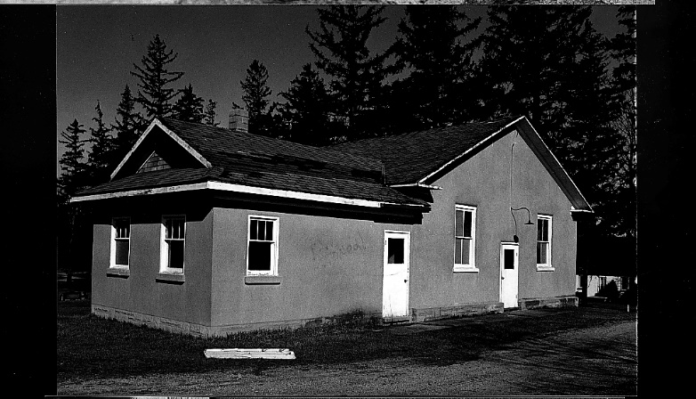
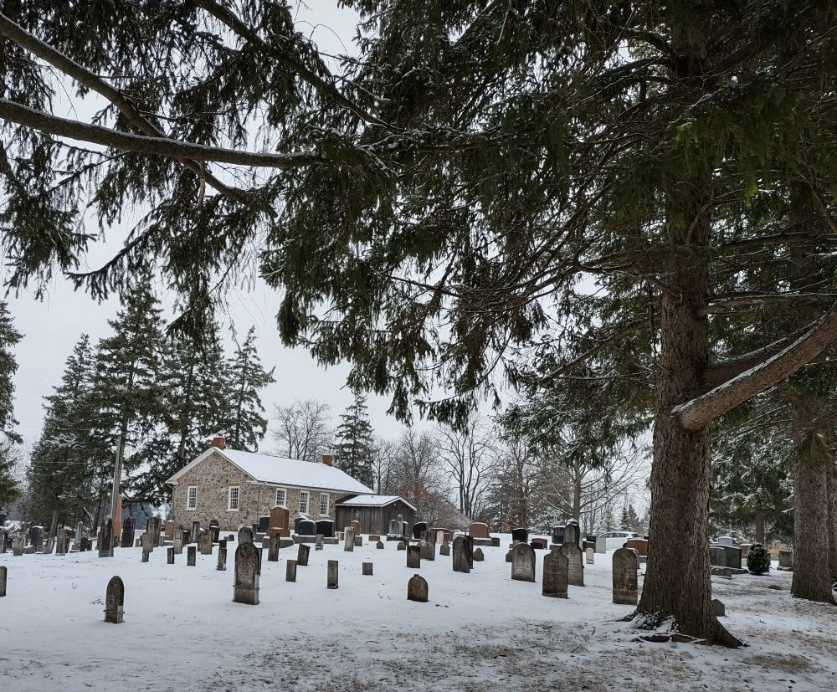
Front and east end view
Pre Restoration photo by Gerry Musselman
Rear view and cemetery.
Photo 2022 by Marion Roes

